Global Carbon Cycle Mixture Model and Carbon Capture

Group Members: Benjamin Davis, Rui Jin, Sebastian Barney

[Intro]

Ever since the industrial revolution in the mid-1800s, human activities have accumulated many carbon dioxide (CO2, or carbon for short), especially from the geological reservoir into the atmosphere. It is of our best interest to find out what methods can we implement to offset the carbon emissions and maintain the carbon balance in the earth system. One of the methods we can use is carbon capturing, which involves in transferring the atmospheric carbon back into its geological form for future sustainability. In this project, we will be using computer programs to simulate the mathematical model behind the earth’s carbon cycle and how the interactions between the different carbon reservoirs might give us insights on how to solve this issue.

[Question 1]

In order to answer any of our questions, it would be necessary for us to set up a mathematical model that captures the behavior of the carbon cycle on earth first. The earth’s carbon cycle system can be modulated by the following differential equation:

$$\frac{dx}{dt}=Ax+a(t)$$

where the matrix x is the amount of CO2 in five different areas that we will look at primarily: atmosphere, biosphere, surface ocean, deep ocean and geological carbon reservoirs, and a(t) is the “forcing term”, which indicates the human impact of carbon emissions. First, we need to figure out what the matrix A is, which means the transferring of carbon between different carbon reservoirs. This problem can be constructed by treating the five reservoirs as five tanks. According to the pre-conditions, the matrix A should look like:

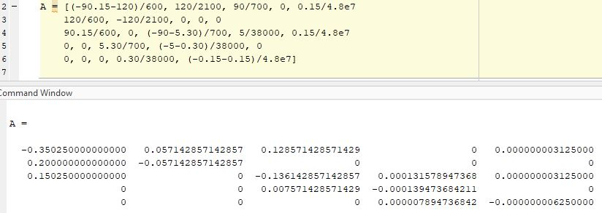

Assuming most carbon emissions caused by human activities after the industrial revolution at 1850, we will set the year 1850 as our starting point and that Ax(1850) = 0, without human interactions. From our MATLAB program, we are able to verify so:

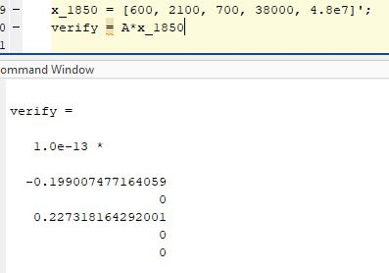

(Note that the values are multiplied by 10 to the negative 13th power, indicating that they are really close to zero except for some rounding differences by MATLAB)

Therefore, if we assume a(t) = 0 at 1850, the initial condition is indeed in equilibrium, as the net transferring of carbon between the different reservoirs should add up to zero. However, at year 2020, the initial condition changes to such that the atmosphere has an additional 500 Gt of carbon, which is transferred from the geological reservoir. Now, we want to find the time in years it takes for the additional carbon to be reduced to 50% (which results in a total of 850 Gt of carbon inside the atmosphere carbon reservoir). We will plot the carbon transformation as the following graph:

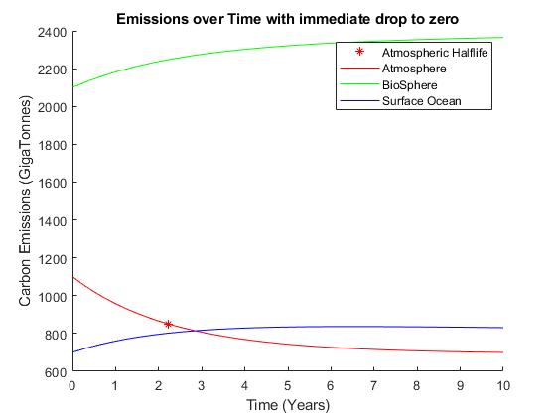

As shown by the asterisk on the atmospheric carbon reserve trend line, the half-life occurs at roughly 2.22 years.

[Question 2]

In question 2, we seek to find an answer in a similar manner to question 1, but with a much simpler 3-by-3 system consisting only the atmosphere (now the flux to surface ocean is at 90 Gt exactly), biosphere, and surface ocean reservoirs. This is because human carbon emissions far exceed some of the smaller reservoirs and can be omitted for a clearer assumption. The matrix B is then set as the following:

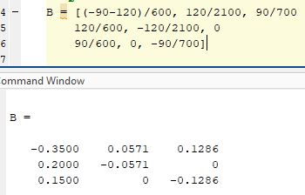

Repeating the process in problem 1, we verify that the result is similar with the initial conditions from year 1850:

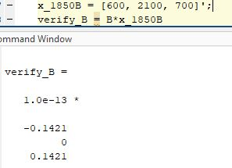

Again, the results are very close to zero except for some small rounding differences. We can also calculate the half-life period for the 2020 pre-conditions with our simplified version of the carbon model:

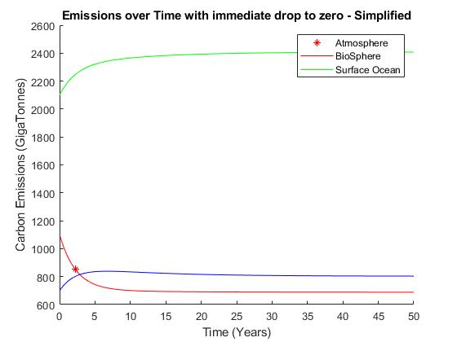

As demonstrated by the graph, it is pretty clear that the half-life of the additional 500 Gt of the carbon emission occurs at around 2.22 years, which is very similar to the more complicated model we created in question 1. Therefore, the simplified model does give a comparable results, indicating that it is a pretty good assumption to leave out those carbon reservoirs.

[Question 3]

From our Gaussian functions, we were able to simulate the carbon emissions under the two scenarios: the “business-as-usual” scenario where no changes are done to the status quo, and the “mitigation plan” scenario where the total emission is limited to 1700 Gt.

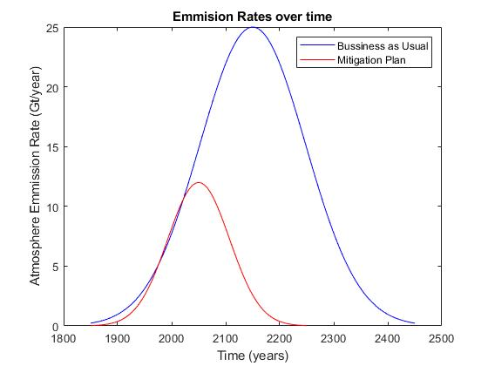

Given those two scenarios, we can attempt to capture the behavior of the carbon emissions and the extrema of carbon amounts. This is done by taking the Euler’s approximation of the derivative of the normal curves generated by the Gaussian functions:

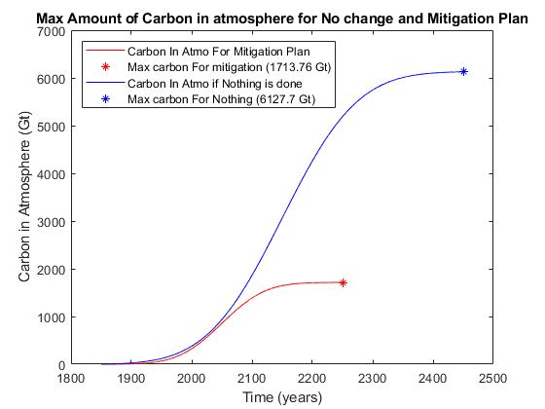

As demonstrated by the graph, the maxima we found is 6127.7 Gt for the current state, and 1713.76 Gt if the mitigation plan is in place.

[Question 4]

Carbon Capture and Sequestration (referred to as CCS for the rest of this essay) is achieved by using a biomass power plant to transfer carbon to energy. In our model, 1% of the biosphere carbon is harvested each year, where only 10% of that harvested amount will be re-emitted to the atmosphere as part of the expenses of using the power plants. To find the difference, we will first look at the carbon emission throughout the period of 200 years without CCS in place:

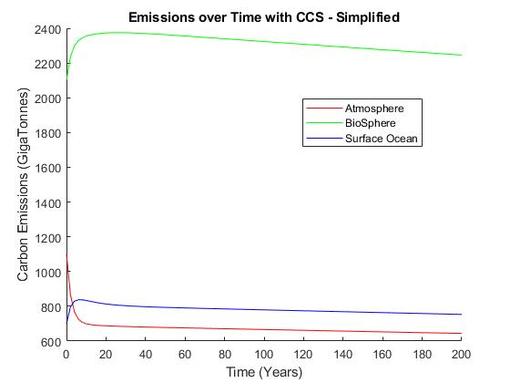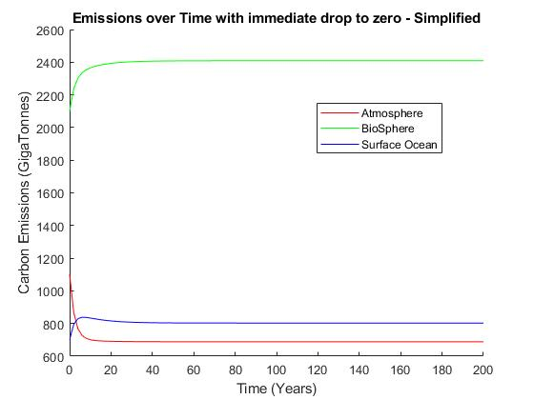However, with CCS actively capturing the carbon, the model looks quite different:

By comparing the two graphs, the effect of CCS is obvious. Both the surface ocean and atmosphere carbon decreases on the long run. Even the biosphere carbon, which increases at first, also decreases as time goes on. On the other hand, from the graph for the situation without CCS, the carbon emission seems to keep constant without visible change throughout the years.

[Question 5]

In conclusion, the CCS seems like a feasible way to decrease the carbon reserve on the larger time scale. Not only does the atmospheric carbon reservoir decrease, the overall carbon emission also seem to decrease as time goes on.

However, this is not to say that CCS is the panacea to solve all carbon issues effortlessly. Just like in our model, some power is unavoidably required for the CCS plants to work, which could again harm the environment and add onto the cost. Our model assumes the re-emittance to be 10% of the amount harvested, but the reality could deviate, possibly in less-than-ideal ways.

It is fair to say that the financial aspect is by far the most concerning and important factor when considering CCS technologies. It must be economically favorable in order to make sense to implement the expensive constructions. In other words, it is crucial for the plants to get sufficient return from the extensive development costs. If the projected outcome is indeed feasible and desirable when compared to the cost, we think the best option to finance the project is by reallocating the current budget for environmental protection.

In terms of where to put the plants, it really depends on the readily available carbon storage the location can have. For instance, the Coastal Plains region including Texas and Georgia has the most geological storage, at around 65% of the storage potential. Alternatively, the state of Alaska and the Rocky Mountains-Northern Great Plains also turn out to be ideal locations for the biomass power plants.

One of the most innovative ideas about turning excess carbon dioxide to usable products cited by Elon Musk’s Carbon XPRIZE program is the carbon vodka made by the Air Company Team. The team is using solar power to extract excess carbon in the air, which can be distilled and filtered to become ethanol, the base ingredient for the alcoholic beverage. This idea is similar in a sense to the CCS technology, as they are both capturing and extracting carbon from the atmosphere. However, CCS is capturing a way larger amount of excessive carbon and it also involves in storing those carbon in the geological carbon reservoir. Of course, that also means that the CCS is more complicated and financial-intensive to implement.

**Bibliography**

“Carbon capture and storage”, *Wikipedia: The Free Encyclopedia.* Wikipedia, The Free Encyclopedia, 22 April, 2022, Web. 23 April, 2022, <https://en.wikipedia.org/wiki/Carbon_capture_and_storage>

“Which area is the best for geologic carbon sequestration?”, *United States Geological Survey*, Web. 24 April, 2022, <https://www.usgs.gov/faqs/which-area-best-geologic-carbon-sequestration>

“Vodka made of CO2”, Carbon XPRIZE, Web. 24 April, 2022, <https://www.xprize.org/prizes/carbon/product/vodka-made-of-co2>